**Software Requirements**

**Specification**

**for**

**Student Activities Management System**

**Version 1.0 approved**

**Prepared by**

**John Kenneth Ferrer**

**Chamber Jose**

**Rempson Dulitin**

**Asia Pacific College**

**November 08, 2016**

***Copyright © 1999 by Karl E. Wiegers. Permission is granted to use, modify, and distribute this document.***

***Software Requirements Specification for <Project> Page ii***

**Table of Contents**

**Table of Contents .......................................................................................................................... ii**

**Revision History ............................................................................................................................ ii**

**1. Introduction..............................................................................................................................1**

1.1 Purpose ............................................................................................................................................ 1

1.2 Document Conventions.................................................................................................................... 1

1.3 Intended Audience and Reading Suggestions.................................................................................. 1

1.4 Product Scope .................................................................................................................................. 1

1.5 References........................................................................................................................................ 1

**2. Overall Description ..................................................................................................................2**

2.1 Product Perspective ......................................................................................................................... 2

2.2 Product Functions ............................................................................................................................ 2

2.3 User Classes and Characteristics ..................................................................................................... 2

2.4 Operating Environment.................................................................................................................... 2

2.5 Design and Implementation Constraints .......................................................................................... 2

2.6 User Documentation ........................................................................................................................ 2

2.7 Assumptions and Dependencies ...................................................................................................... 3

**3. External Interface Requirements ...........................................................................................3**

3.1 User Interfaces ................................................................................................................................. 3

3.2 Hardware Interfaces ......................................................................................................................... 3

3.3 Software Interfaces .......................................................................................................................... 3

3.4 Communications Interfaces ............................................................................................................. 3

**4. System Features........................................................................................................................4**

4.1 System Feature 1.............................................................................................................................. 4

4.2 System Feature 2 (and so on)........................................................................................................... 4

**5. Other Nonfunctional Requirements .......................................................................................4**

5.1 Performance Requirements.............................................................................................................. 4

5.2 Safety Requirements ........................................................................................................................ 5

5.3 Security Requirements ..................................................................................................................... 5

5.4 Software Quality Attributes ............................................................................................................. 5

5.5 Business Rules ................................................................................................................................. 5

**6. Other Requirements ................................................................................................................5**

**Appendix A: Glossary....................................................................................................................5**

**Appendix B: Analysis Models .......................................................................................................5**

**Appendix C: To Be Determined List............................................................................................6**

**Revision History**

|  |  |  |  |
| --- | --- | --- | --- |
| **Name** | **Date** | **Reason For Changes** | **Version** |
| Initial Draft | 11/08/2016 | Initial Draft version | 1.0 |
|  |  |  |  |

**1. Introduction**

**1.1 Purpose**

*The APC Student's Activities Office (SAO), in cooperation with different extra-curricular organizations in Asia Pacific College (APC), handle various transactions such as re/accreditation, financing, event handling and much more. because of the use of outdated technology and old school methods, transactions among SAO and the officers of extra-curricular organizations seemed to be inefficient concerning time management and lack of collaboration.*

*With the Organization's need for a better solution, the Project Team has grabbed the opportunity to work with APC SAO to develop a system called Student Activities Management System. The Student Activities Management System is a Project that aims to enhance the collaboration between the Student Activities Office (SAO) and the different organizations within Asia Pacific College (APC). Moreover, this will help in reduction of workloads and solve problems which are most of the time, due to the use of large volumes of papers and manual methods of document processing for every transaction the office is doing.*

**1.2 Document Conventions**

*The document is prepared using Microsoft Word 2016; has used the font type ‘Times New Roman’ for the headings and ‘Arial’ for the contents. The fixed font size that has been used to type this document is 11pt with 1.0-line spacing. It has used the bold property to set the headings of the document.*

**1.3 Intended Audience and Reading Suggestions**

*The intended audience of this document would be client and specific user and developers like SAO and Student Organizations, and developers with the goal to refer and analyze the data. The SRS document can be utilized as a part of any case with respect to the requirements of the project and the arrangements that have been taken. The document would final provide a reasonable thought regarding the system that is building.*

*Brief outline of the document is:*

1. *1. Overall Description*
2. *2. System Features*
3. *3. External Interface Requirements*
4. *4. Non-Functional Requirements*

**1.4 Product Scope**

*The purpose of the project is to provide the SAO a Document Library Management System to make their work efficient. It will make the transaction or process of the activities more easy and effective for the users. It will help them organize the documents needed to able to process an event or accomplishment. Therefore, this project will only provide what the clients need to able to eliminate the manual process of the documents.*

**1.5 References**

* *http://projects2.apc.edu.ph/wiki/index.php/Project_-_Student_Activities_Management_System_-_105*

**2. Overall Description**

**2.1 Product Perspective**

*The Student Activities Management System is a project developed to replace the existing manual process of the APC Student Activities Office (SAO) of managing its documents and other transactions with other organizations. The system will be connected to the World Wide Web and can be accessed by any of the authorized users in and outside of the school campus*

**2.2 Product Functions**

*Major functions of SAO Document Library Management System*

1. Event Organizer
2. Document Sharing
3. Document Upload

**2.3 User Classes and Characteristics**

*SAO Head / Director*

* *The Student Activities Office (SAO) Head plays the System Administrator user role of the system and is responsible for posting document forms that are required to be filled in by different organizations.*

*Organizational Heads / Representatives*

* *System users belonging to the Standard Users group. The SAO Head and Representatives / Organizational Heads used to have the same privileges but the SAO head do have a management authority within the system which allows configuration of system settings, etc.*

**2.4 Operating Environment**

*The Student Activities Management System should work with machines running Windows XP or later. Moreover, a browser is required to access the system and it should work with the following internet browsers:*

* *Microsoft® Internet Explorer / Edge*
* *Mozilla Firefox*
* *Google Chrome*
* *Opera*
* *Safari*

*Taking into consideration the server environment into where the system will be deployed, the system will be initially installed on a cloud hosting platform called IBM Bluemix, and later, will use the operating environment specifications that the device that the institution will provide*

**2.5 Design and Implementation Constraints**

*The system is subject to the following design and implementation constraints:*

* *The system should use a MySQL Database*
* *All scripts and codes must be written in PHP*
* *The PHP codes contained in the scripts should comply with the framework coding standards*

**2.6 User Documentation**

*As a new project, the system should provide a help system within the web application that will make its users be familiarized with different system functions and features*

**2.7 Assumptions and Dependencies**

A third-party application is necessary for the deployment of the system.

**3. External Interface Requirements**

**3.1 User Interfaces**

### Login Page

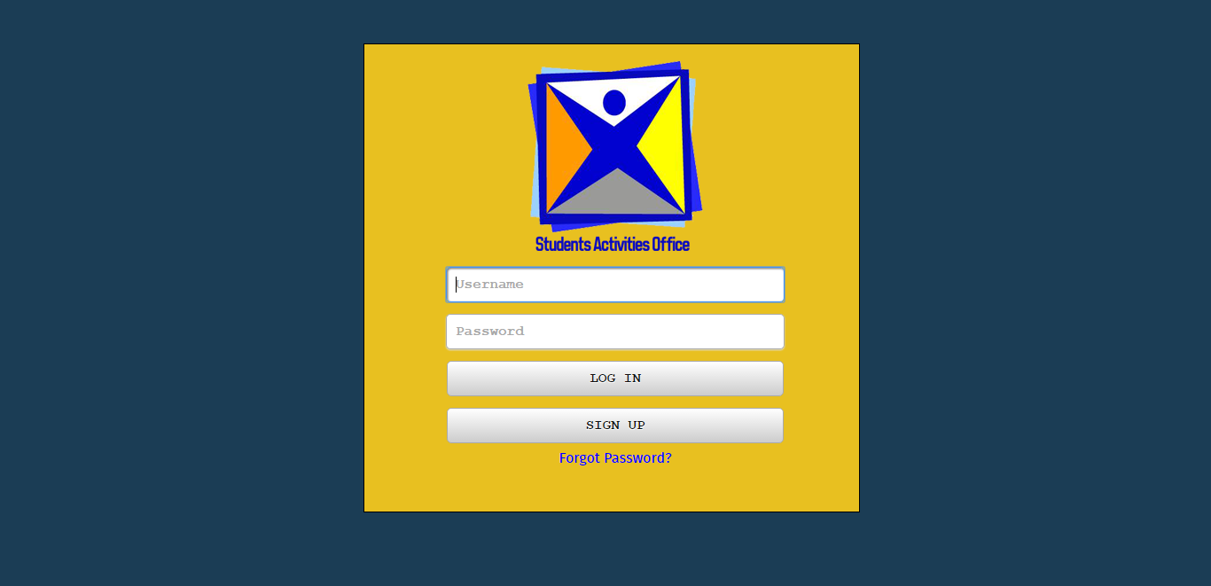

### Organization Page

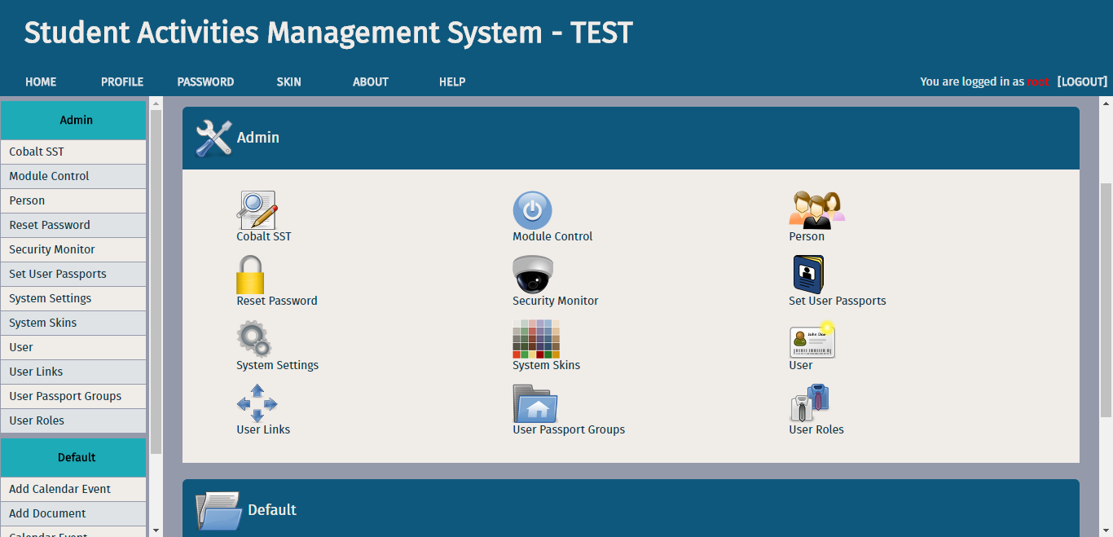

### Calendar Event

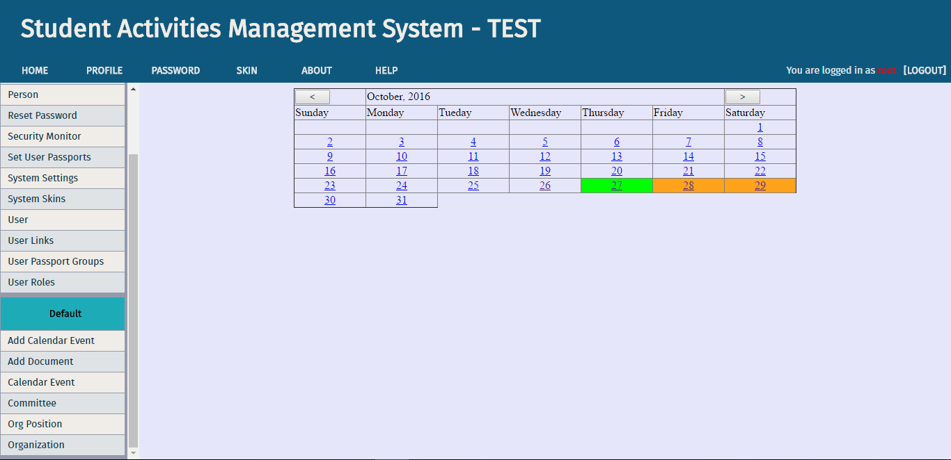

### Upload Documents

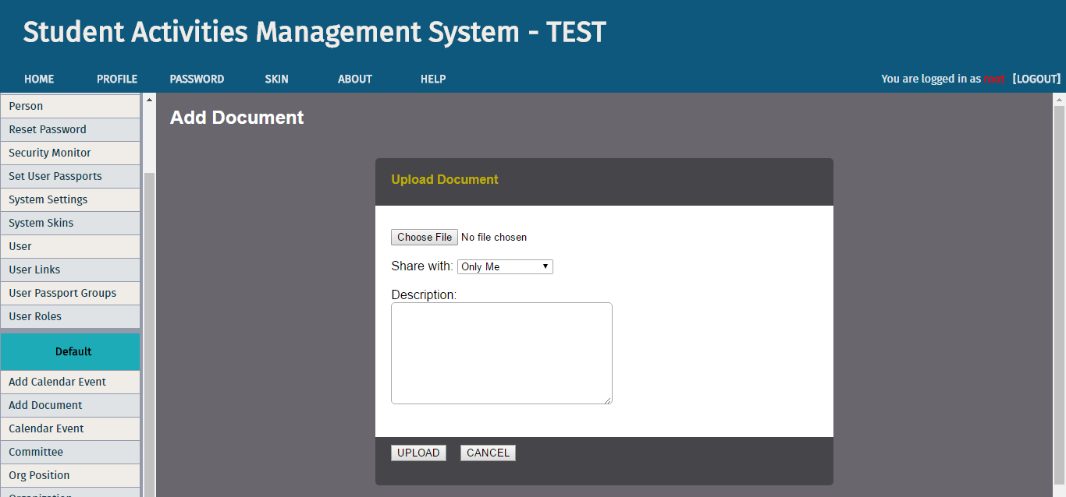

### Administrator Page

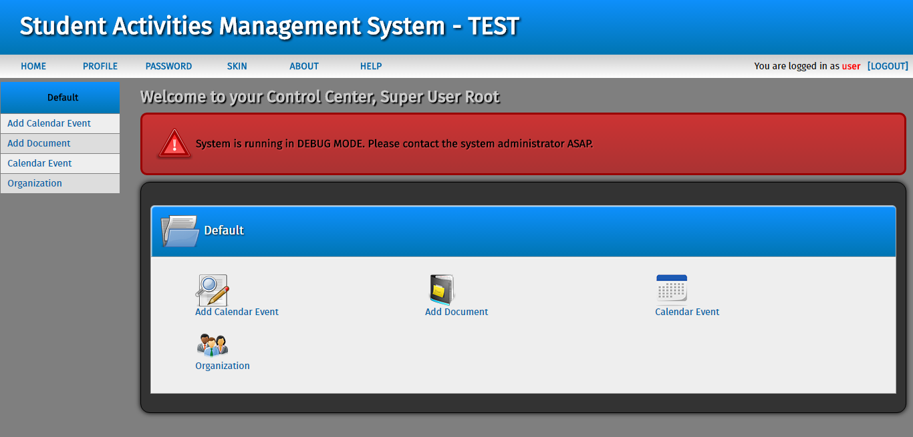

### Signup

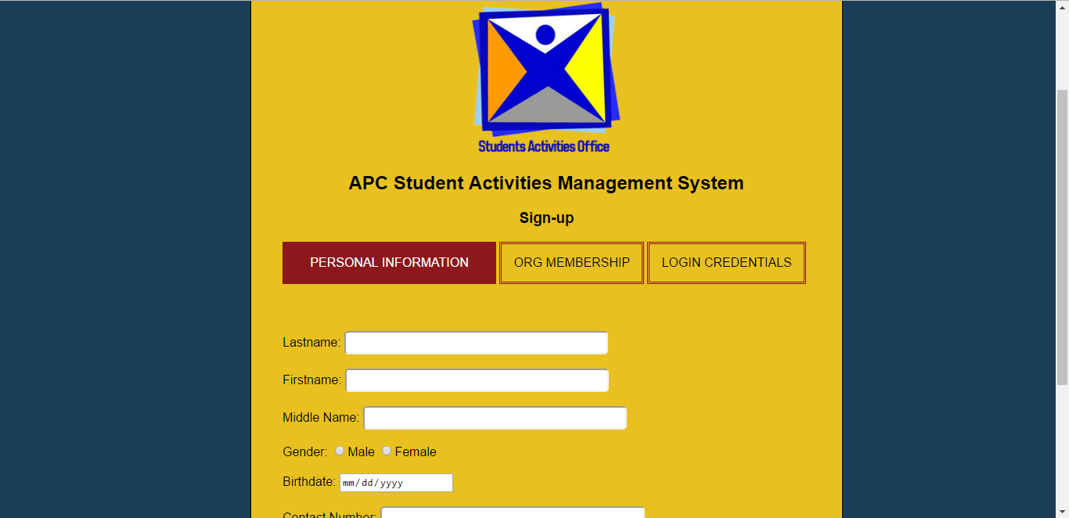

### Forgot Password

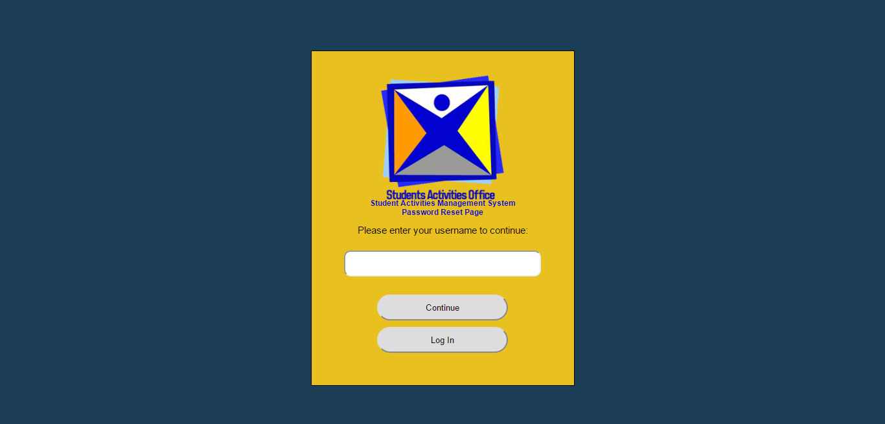

**3.2 Hardware Interfaces**

Hardware:

1. *For (Server side and client side)*
2. *For (Browser based and mobile)*
3. Operating System: Supports all known operating systems, such as Windows, Linux
4. Computer: 512MB+ RAM, monitor with minimum resolution of 1024x768, keyboard, and mouse
5. Hard Drive: should be in NTFS file-system formatted with minimum 10 GB of free space
6. Printer: need to be used to print reports and notes

Software:

1. Software is designed to run on any platform above Microsoft Windows 7
2. Microsoft .NET Framework 4.0 or above
3. Microsoft SQL Server Management Studio Express 2010
4. Software can be used on any browsers

**3.3 Software Interfaces**

*The computer, this software going to be installed, needs to have Windows Operating System above Windows 7. On that Windows platform, .Net 4.0 will be installed and that will be the platform the specific software will be run. There will be an ADO.NET data transmission with the Microsoft SQL Server Management Studio Express 2010 R2 edition that will be installed in the same computer. Then, the software can be used on any browsers.*

**3.4 Communications Interfaces**

*The software will be having an association with e-mails, the software will make use of the email by either sending updates about the reservation made, or confirming a recently made account. Since the application is a website, it also is associated, of course, with a web browser. To access the website, the user must be first connected to an internet connection and must have a web browser of any kind. The application will use the Hypertext Transfer Protocol for data communication. With that, security features must also be implemented since there are possible sensitive data that will be gathered during a transaction. When a customer, makes a reservation online, credentials are needed for the application to confirm that reservation, if not careful, these pieces of information containing user identity and much more might be used by other people for illegal purposes.*

**4. System Features**

**4.1 Password Resetting**

4.1.1 Description and Priority

*A system user who forget his / her password may be able to use the system’s password reset feature to change his / her password. Priority: 5*

4.1.2 Stimulus/Response Sequences

*Stimulus: User requests the system to reset his / her password*

*Response: System request for the required credentials of the user (i.e, username) to reset his password*

*Stimulus: The user will enter his / her username in the text field*

*Response: The system will check if the details inputted in the page exists in the database. If yes, system will generate a random token and send it to user’s email*

Stimulus: The user has already received the reset code for his / her account

Response: The system will validate if the entered reset code is associated with any account in the database. If yes, the system will ask the user for a new password

Stimulus: The user has entered his / her new password

Response: The system will hash the newly created password and will update the old one with the new ones in the database

4.1.3 Functional Requirements

*Password Reset: The system should let the registered users to reset their passwords at any time*

*Password Reset, Username: The system must first confirm if the user is a bona fide authorized user in the system*

*Password Reset, Email: If the system has validated that the username exists in the database, the system will fetch the email address and send a password reset procedure to the user*

*Password Reset, New password: After the system, has validated the credential entered by the user, he / she will be required to enter a new password which will be later hashed by the system*

**4.3 Set a Calendar Event / Appointment**

4.3.1 Description and Priority

*Another major feature of this system is calendar event / appointment setting. Aside from managing documents of different organizations, this system feature allows every system user to manage their organization-related appointments such as meetings, etc. Priority: 8*

4.3.2 Stimulus/Response Sequences

*Stimulus: User has requested to add a new calendar event*

*Response: System requested the user to enter the required pieces of information / details*

*Stimulus: The user has selected an event date / time*

*Response: The system will validate the date selected. If the date/time is past to the current date/time, the system will trigger an error*

*Stimulus: User has completed filling in the required fields for setting an appointment.*

*Response: The system will re-validate the inputs for errors. If no errors are found, the inputted values will be entered the database*

4.3.3 Functional Requirements

*Calendar Event: All system users are granted to add an appointment for organization-related activities*

*Calendar Event, Date: Once the user has selected a date, the system will validate if the date for an event is valid or not*

*Calendar Event, Venue: The system will check if a particular event has a conflict with other event with the same venue of the same date*

**5. Other Nonfunctional Requirements**

**5.1 Performance Requirements**

*The Student Activities Management System must be interactive and the delays involved must be less. So, in every action-response of the system, there are no immediate delays.*

**5.2 Safety Requirements**

*Delivery of information should be securely transmitted to the server without any changes in information.*

**5.3 Security Requirements**

*The following security rules must be implemented in order to ensure the security and integrity of the system and its components:*

* *System will have different types of users and every user has access constraints*
* *Proper user authentication should be provided*
* *No one should be able to hack user's password*
* *System will use secured database*

**5.4 Software Quality Attributes**

Additional quality characteristics of the system is the usability and security.

* **Usability**
  + - * As the system is easy to handle and navigates in the most expected way with no delays.
* **Security**
  + - * The main security concern is for users account hence proper login mechanism should be used to avoid hacking.

**5.5 Business Rules**

*Since the Students Activities Office handles a lot of transaction from different organizations, the system, the developers have already incorporated some features of the system that might help the department to be flexible in performing its tasks. System features included is the document sharing option. Since it is assumed that the SAO Head may encounter a lot of document transactions any time, it is the job of the Student Activities Management System to manage those documents that are uploaded by every user and to separate the access across different files.*

*Another business rule of the department is, every user, if they are a bona fide member of any organization within Asia Pacific College, can also set one or more of their personal appointments at a time. In relation to this rule, the system has been incorporated with a calendar event management module to enable every entities / user in the system to manage not only document transactions but also their personal appointments.*

**6. Other Requirements**

**Appendix A: Glossary**

*Acronyms and Abbreviations:*

1. *SAO – Student Activities Office*
2. *PGP – Pretty Good Privacy*
3. *SOAR – Student Organization Association of Regents*

**Appendix B: Analysis Models**

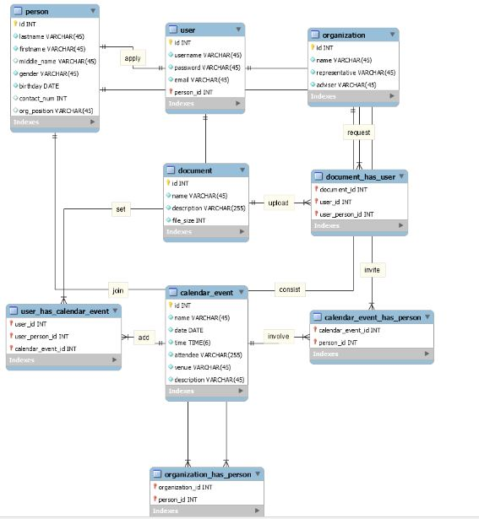

**Appendix C: To Be Determined List**

Presently there are no remaining TBDs. All TBDs have been tracked to their closure.